K.S.R.M COLLEGE OF ENFGINERING (AUTONOMOUS)

III B.TECH VI SEM

MECHANICAL ENGINEERING

3D PRINTING LAB MANUAL

2304212 | B.Tech. ME, VI-SEMESTER  3D PRINTING LAB  (ME) | L | T | P | C
 |  | 0 | 0 | 2 | 1

Pre-Requisites: Induction and Synchronous Machines
Course Objectives:
- Understand different methods of 3D Printing
- Gain knowledge about simulation of FDM process
- Estimate time and material required for manufacturing a 3D component

Course Outcomes:
On successful completion of the course, student will be able to
- Analyze different types of 3d Printing techniques
- Identify parameters for FGF process
- Predetermine the performance and regulation of 3-phase synchronous machines.
- Able to apply Post processing techniques on 3D printed components
- Able to operate Industrial robot for 3d printing
- Make decisions on which material is suitable for 3D printing

However, the mapping values depend on the syllabus. Also, the CO6 shall be rephrased if Finances and Optimization are involved in the syllabus.

The number of COs other than CO4, CO5 AND CO6 depends on the Lab Course syllabus.

CO – PO & PSO Mapping:
 | PO1 | PO2 | PO3 | PO4 | PO5 | PO6 | PO7 | PO8 | PO9 | PO10 | PO11 | PSO1 | PSO2 | PSO3
 | K | A | D | CP | T | SUS | ET | TW | C | PMF | LLL
CO1 | 3 | 2 | 2 | - | 1 | - | - | - | - | - | 1 | 3 | - | -
CO2 | 3 | 3 | 3 | 2 | 1 | - | - | - | - | - | 1 | 3 | - | -
CO3 | 3 | 3 | 3 | - | 2 | - | - | - | - | - | 1 | 3 | - | -
CO4 | - | - | - | - | 3 | 2 | 3 | - | - | - | - | - | - | -
CO5 | - | - | - | - | - | - | - | 3 | 3 | - | - | - | - | -
CO6 | - | - | - | - | - | - | - | - | - | 2 | 3 | - | - | -

List of Exercises/ List of Experiments:

Minimum Ten experiments are to be conducted.

- Modelling of Engineering component and conversion of STL format.
- Slicing of STL file and study of effect of process parameter like layer thickness, orientation, and infill on build time using software
Exercise 1: Component-1
Exercise 2: Component-2
- 3D Printing of modelled component by varying layer thickness
- 3D Printing of modelled component by varying orientation.
- 3D Printing of modelled component by varying infill.
- Modelling of component using 3D Scanner of real-life object of unknown dimension in reverse engineering.
- 3D Printing of above modelled component.
- 3D printing the component using FGF large scale robotic 3D printer.
- 3D printing the component using PETG material in large scale robotic 3D printer.

10. Identifying the defects in 3D Printed components
REFERENCE BOOKS/LABORATORY MANUALS:

Ian Gibson, David W. Rosen, Brent Stucker, Additive Manufacturing Technologies: Rapid Prototyping to Direct Digital Manufacturing, 1/e, Springer, 2010,

Web Resources:
https://www.hubs.com/knowledge-base/introduction-fdm-3d-printing/

Module 1:
Introduction to Prototyping, Working of 3D Printer, Types of 3D printing Machines: Exp 1: Modelling of Engineering component and conversion of STL format.
Exp 2: Slicing of STL file and study of effect of process parameter like layer thickness, orientation, and infill on build time using software.
Exercise 1: Component-1
Exercise 2: Component-2
Introduction to Prototyping
Prototyping is defined as the process of iteratively producing a custom model. A prototype is a work in progress, something that is still being improved. 3D printers are perfect for prototyping because they make it incredibly easy to make custom objects using a wide range of materials. From simple, rigid fixtures to flexible, organic geometries, the array of things 3D printers can make is constantly expanding.
Additive manufacturing is a formal name of 3D printing, a previously used technology for rapid prototyping Additive manufacturing also facilitates the evaluation and testing of designs before producing the finished product .In addition, this technique is a breakthrough in the world of technology, namely the ability to make a prototype at a low cost and a simple process . The application of 3D printing products has also been widely used in the automotive and medical industries The existence of 3D printing technology in manufacturing has brought major changes to the world. The rapid prototyping technology was first invented by Chuck Hall using a stereo lithographic (SLA) 3D printer. He used UV light to form plastic into layers. Scott Crump introduced another technique of 3D printing called fused deposition modeling (FDM) in 1988 by melting and pouring the plastic into a thin layer. Further, he applied the CNC to automate the process. With this technology, his machine melted and layered the plastic filament on a flat surface.
Types of 3D Printing:Varieties of 3D printing technologies have been developed with the different function. According to ASTM Standard F2792 . ASTM catalogued 3D printing technologies into seven groups, including the binding jetting, directed energy deposition, material extrusion, material jetting, powder bed fusion, sheet lamination and vat photo polymerization. There are no debates about which machine or technology function better because each of them has its targeted applications. Nowadays, 3D printing technologies are no longer limited to prototyping usage but are increasingly also being used for making variety of products .
Binder jetting: Binder jetting is a rapid prototyping and 3D printing process in which a liquid binding agent is selectively deposited to join powder particles. The binder jetting technology uses jet chemical binder onto the spread powder to form the layer . The application of the binder jetting is would be producing the casting patterns, raw sintered products or similar large-volume products from sand. Binder jetting can print a variety of materials including metals, sands, polymers, hybrid and ceramics. Some materials like sand not required additional processing. Moreover, the process of binder jetting is simple, fast and cheap as powder particles are glued together. Lastly, binder jetting also has the ability to print very large products.
Directed energy deposition: Directed energy deposition is a more complex printing process commonly used to repair or add additional material to existing components . Directed energy deposition has the high degree control of grain structure and can produce the good quality of the object. The process of

directed energy deposition is similar in principle to material extrusion, but the nozzle not fixed to a specific axis and can move in multiple directions. Furthermore, the process can be used with ceramics, polymers but is typically used with metals and metal-based hybrids, in the form of either wire or powder. The example of this technology is laser deposition and laser engineered net shaping (LENS) . Laser deposition is the emerging technology and can be used to produce or repair parts measured in milimeter to meters. Laser deposition technology is gaining attraction in the tooling, transportation, aerospace, and oil and gas sectors because it can provide scalability and the diverse capabilities in the single system . Meanwhile, laser LENS can exploit thermal energy for melting during the casting and parts are accomplished subsequently .
Materials extrusion: Material extrusion-based 3D printing technology can be used to print multi- materials and multi-colour printing of plastics, food or living cells . This process has been widely used and the costs are very low. Moreover, this process can build fully functional parts of product [8]. Fused deposition modelling (FDM) is the first example of a material extrusion system. FDM was developed in early 1990 and this method uses polymer as the main material . FDM builds parts layer- by-layer from the bottom to the top by heating and extruding thermoplastic filament. The operations of FDM are as follows: I. Thermoplastic heated to a semi-liquid state and deposits it in ultra-fine beads along the extrusion path . II. Where support or buffering needed, the 3D printer deposits a removable material that acts as scaffolding. For example, FDM uses hard plastic material during the process to produce 3D bone model.
Materials jetting: According to ASTM Standards, material jetting is a 3D printing process in which drop by drop of build material is selectively deposited. In material jetting, a printhead dispenses droplets of a photosensitive material that solidifies, building a part layer-by-layer under ultraviolet (UV) light . At the same time, material jetting creates parts with a very smooth surface finish and high dimensional accuracy. Multi-material printing and a wide range of materials such as polymers, ceramics, composite, biological and hybrid are available in material jetting .
Powder bed fusion:The powder bed fusion process includes the electron beam melting (EBM), selective laser sintering (SLS) and selective heat sintering (SHS) printing technique. This method uses either an electron beam or laser to melt or fuse the material powder together. The example of the materials used in this process is metals, ceramics, polymers, composite and hybrid. Selective laser sintering (SLS) are the main example of powder based 3D printing technology. Carl Deckard developed SLS technology in 1987. SLS is 3D printing technology that’s functionally in fast speed, has high accuracy, and varies surface finish . Selective laser sintering can used to create metal, plastic, and ceramic objects . SLS used a high power laser to sinter polymer powders to generate a 3D product. Meanwhile, SHS technology is another part of 3D Printing technology uses a head thermal print in the process to melt the thermoplastic powder to create 3D printed object. Lastly electron beam melting enhances an energy source to heat up the material .
Sheet lamination:According to ASTM definition, sheet lamination is the 3D printing process in which sheet of materials are bond together to produce a part of object .The example of 3D printing technology that uses this process are laminated object manufacturing (LOM) and ultrasound additive manufacturing (UAM) . The advantages of this process are sheet lamination can do full-colour prints, it relatively inexpensive, easy of material handling and excess material can be recycled. Laminated object manufacturing (LOM) is capable to manufacture complicated geometrical parts with lower cost

of fabrication and less operational time . Ultrasound additive manufacturing (UAM) is an innovative process technology that uses sound to merge layers of metal drawn from featureless foil stock.
Vat Photo polymerization:The main 3D printing technique that frequently used is photo polymerization, which in general refers to the curing of photo-reactive polymers by using a laser, light or ultraviolet (UV) . The example of 3D printing technologies by using photo polymerization is stereo lithography (SLA) and digital light processing (DLP). In the SLA, it was influenced by the photo initiator and the irradiate exposure particular conditions as well as any dyes, pigments, or other added UV absorbers [19]. Meanwhile, digital light processing is a similar process to Stereo lithography that works with photopolymers. Light source is the major difference. Digital Light Process uses a more conventional light source, such as an arc lamp with a liquid crystal display panel. It can apply to the whole surface of the vat of photopolymer resin in a single pass, generally making it faster than Stereo lithography . The important parameters of Vat Photo polymerization are the time of exposure, wavelength, and the amount of power supply. The materials used initially are liquid and it will harden when the liquid exposed to ultraviolet light. Photo polymerization is suitable for making a premium product with the good details and a high quality of surface.

To Study of 3D Printing
Introduction: - 3D printing allows for rapid prototyping and onsite manufacturing of products. Initially done with plastic, 3D printing now uses new techniques with new materials, such as aluminum, bronze, and glass. Biomaterials are also being incorporated, such as 3D printing ear cartilage and liver tissue. As the 3D printing industry grows, 3D printing will become a big part of many engineering fields.
Flow layout of Pre 3D Printing Components of 3D Printer: -

axes
Fixed Rods The three axes that the 3D printer utilizes are on the Cartesian coordinate system. The linear fixed rods are maintained at right angles to each other and each represents a coordinate axis.
Movement The timing belts and pulleys allow the movement of the hot end (or the print bed, depending on the type of 3D printer) along each axes according to the g-code (generated by slicing software). The stepper motors power this movement.

Extruder
Extrusion is the feeding of filament into the hot end of the 3D printer. This movement is also powered by a stepper motor.
Retraction This mechanism is the pulling of the melted filament from the hot end. This movement is primarily programmed through the g-code to prevent the formation of unwanted filament creating a bridge between two areas. The bridging of unwanted filament is referred to as stringing or the formation of cobwebs.
Dual Extrusion Some models of 3D printers are equipped with dual extrusion capabilities. This allows for mixed material objects to be printed. Dual extrusion can be
used to print out complex objects with a different colour material as the support, making it easy to differentiate between the object and the support.

- Hot End
The hot end is heated to temperatures ranging from 160 C to 250 C, depending on the type of filament to be used. The hot end melts the filament and pushes the melted filament through the nozzle. The hot end needs to be thermally insulated from the other components of the 3D printer to prevent any damage.
- Print Bed
Heated Print beds that are heated improve print quality of 3D printed objects. The heated bed is heated to the glass transition temperature of the filament being used. This allows the model layers to slightly melt and stick to the heated bed.
Non-Heated Print beds that are not heated require adhesion in the form of glue, tape, hairspray, etc. In the innovation lab, painters tape is frequently used for adhesion.
- Filament
Filament is a consumable used by the 3D printer to print layers. Filament comes in a variety of materials and colors. Filament can be composed of metal, wood, clay, biomaterials, carbon fiber, etc.
  - ABS: - ABS is a thermoplastic that needs to be heated to temperatures from 210C to 250C. ABS can only be printed on a 3D printer with a heated bed, which prevents the cracking of the object. When ABS is heated, it emits a strong unpleasant odor. ABS requires a complete enclosure while printing.
  - PLA: - PLA is a thermoplastic that needs to be heated to temperatures from 160C to 220C. PLA is also biodegradable and emits slight odors. PLA is most frequently used in the Innovation Lab on all 3D printers.
Preparing your 3D Model in CAD Software: -
CAD software is used to create 3D models and designs. This software is available on our computers and the level of difficulty varies. With the exception of Sketch up Pro and the industry standard software mentioned, all of these programs are available on the innovation lab computers.
Solid works main idea is user to create drawing directly in 3D or solid form. From this solid user can assemble it directly on their workstation checking clashes and functionality of it. Creating drawing is pretty easy just drag and drop the solid to drawing block.
Preparing your 3D Model for print in Idea maker software:-
These are following step for 3D printing of model
- Install the 3D print software idea maker
- Check repair option in this software
- Set the nozzle parameter and build tack temperature according to the printer guide. Step:-1 Prepare the design Model using Designing Software(Solids Work,Autocad etc.) Step:-2 Convert the designed Model file in Stl ,obj format.
Step:-3 Prepare the design model for printing Using Software Idea Maker and Ultimaker. Then set all parameter (nozzle temp., buildtak temp and support) and also repair your design using software option. Then after generate the file in gcode format
Step:-4 ON the 3D Printer and load the filament in nozzle and give the command print by using 3D Printing Machine.
Precaution of 3D Printer machine: -
These are some following precaution when you print the design in 3D Printer
- Mechanical: Do not place limbs inside the build area while the nozzle is in motion. The printer nozzle moves in order to create the object.
- High Temperature: Do not touch the printer nozzle – it is heated to a high temperature in order to melt the build material.
- Always buy replacement parts from the manufacturer for safety related equipment

- Choose an area that has adequate ventilation and exhaust capability Safety Equipment: -
  - Safety Glasses
  - Gloves (recommended for postprocessing) Application of 3D Printer: -
  - Automotive
  - Marine
  - Aerospace Advantages: -
  - Medical
  - Engineering
  - Architecture
  - Complex shapes
  - Freedom for design
  - Customize parts
  - Less waste
  - Fewer unsold products
  - Less transport Limitations: -
  - Time
  - Cost
  - Skill
  - Materials

How to create simple box
In this First exercise we will design a simple Box as seen in the figure below. This exercise will build the foundations of how to design 3D parts in SolidWorks and introduce several fundamental features such as Sketching, Dimensioning and Extruding and printing on rise 3d machine. Let’s begin. Check all Electrical connections.
Step1. First we install 3d design software in your computer like solids work auto cad, etc. Step2. Open the solids work software and click New option in software window
- Click New, Option
- Click Part and OK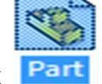 .
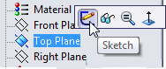
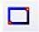
- Click on Top Plane and click Sketch.

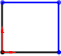
- Click Rectangle origin.

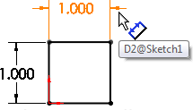
- Click Smart Dimension 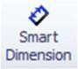, click side edge and click top edge to dimension it as 1.0in x 1.0in.

- Click Features>Extruded Boss/Base
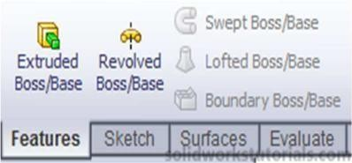

set D1 as 1.0in
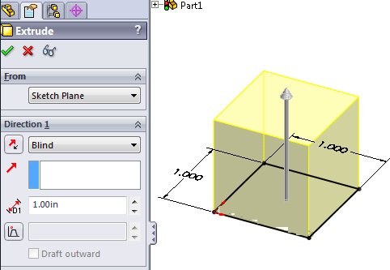

and click.

- It’s done. Simple Right?
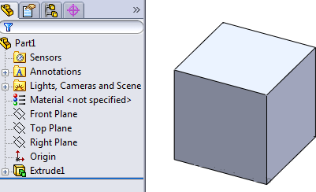

This exercise will build the foundations of how to Print the design in 3D Printer. Let’s begin. Check all Electrical connections. These are following steps before start the printing.
Step 1.:- first we install the software related the 3D printer(idea maker,ultimaker etc.)In idea maker first open the software and click the open file option as shown in below figure.
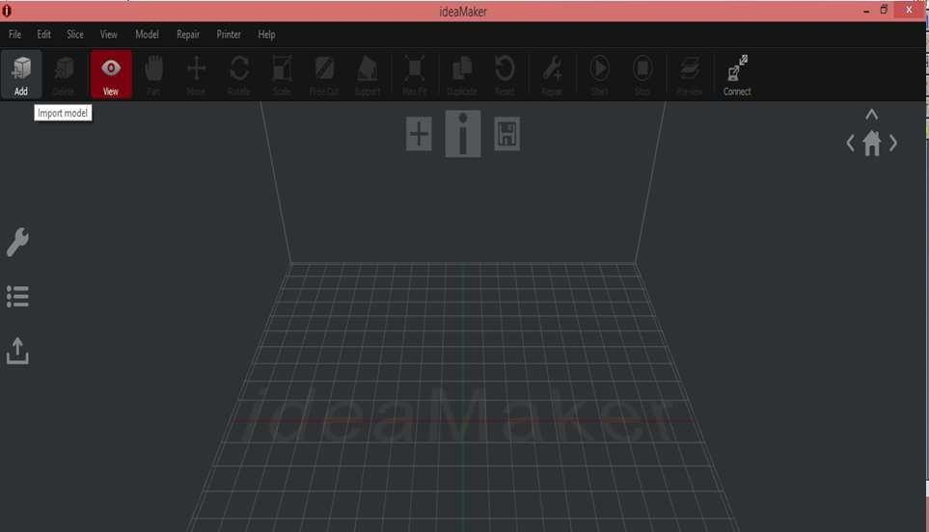
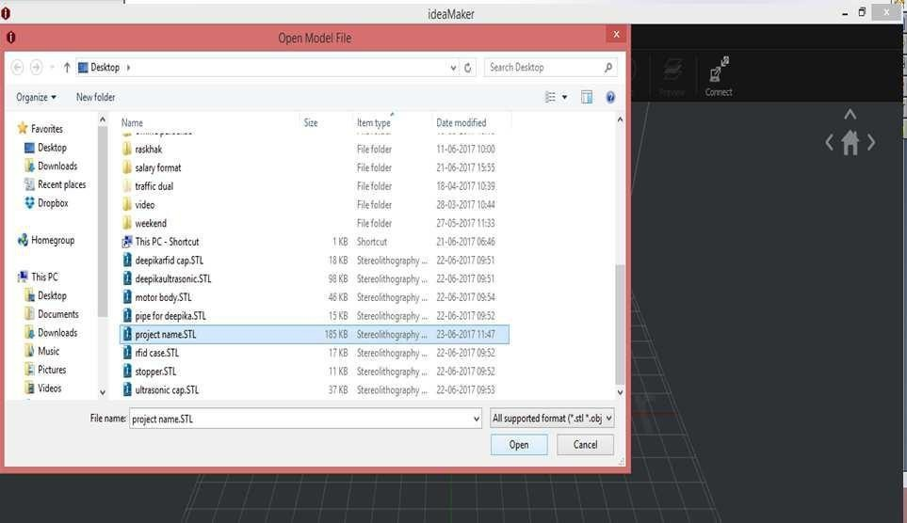

Step 2.:- select the Pan option and select the extruder (left of right) for printing the design and then after select the Repair option for auto correction of design of software parameter as shown in below figure.
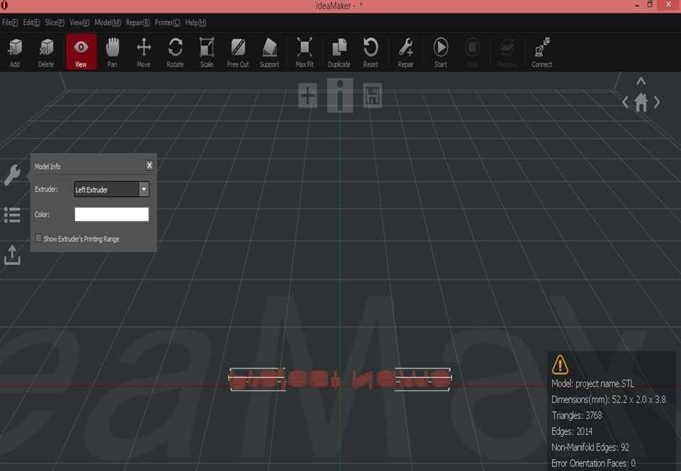
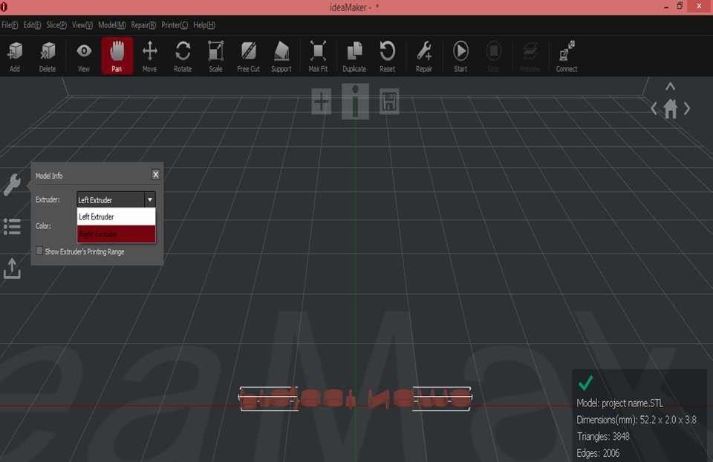

Step 3.:- select the Move option for design print postion in buildtack plate and then after select the Rotate option for rotate the design easily printed and used low print material as shown in below figure.
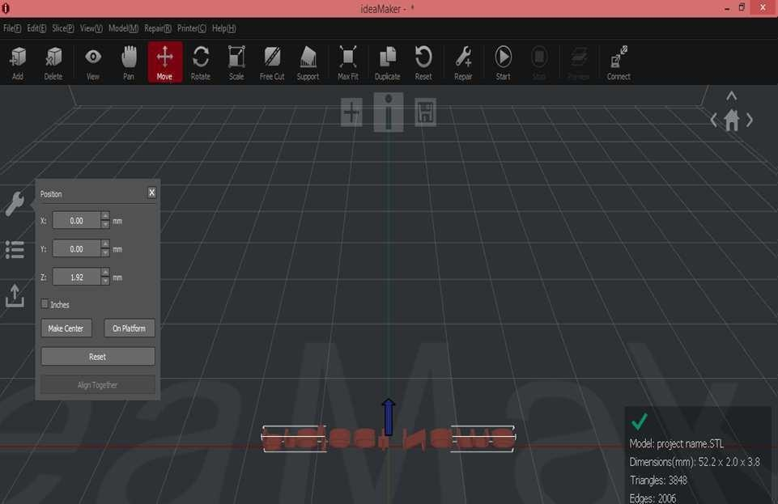
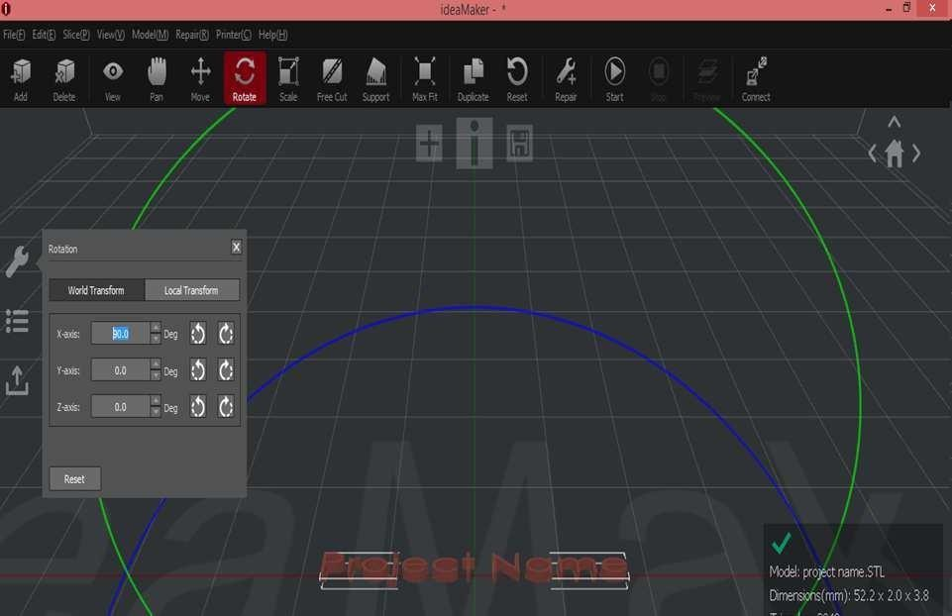

Step 3.:- select the Scale option for design scale according to buildtack plate area and then after click the start option and select printing option standard as shown in below figure.
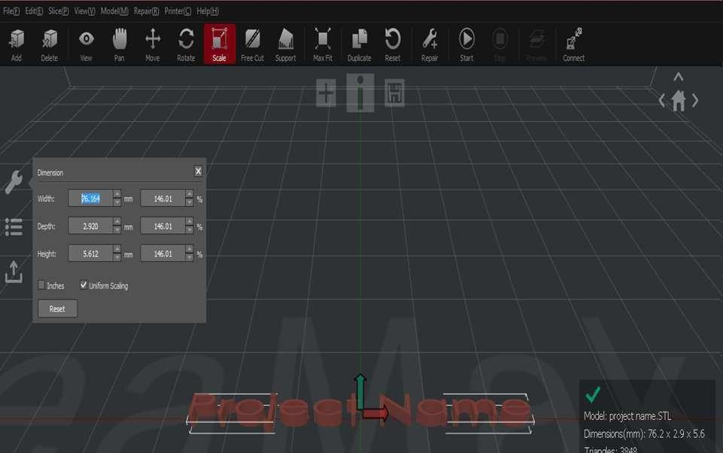
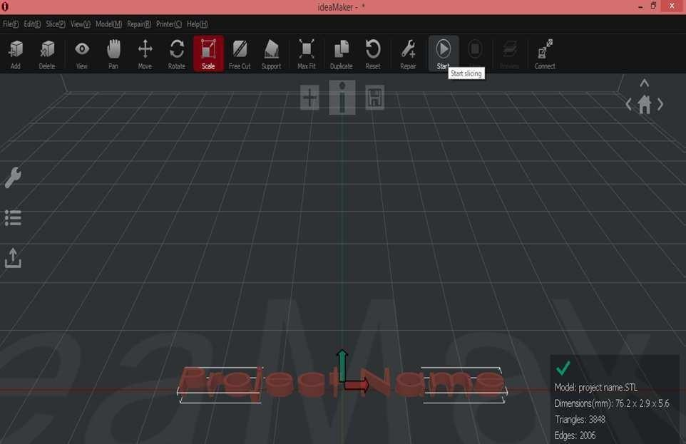

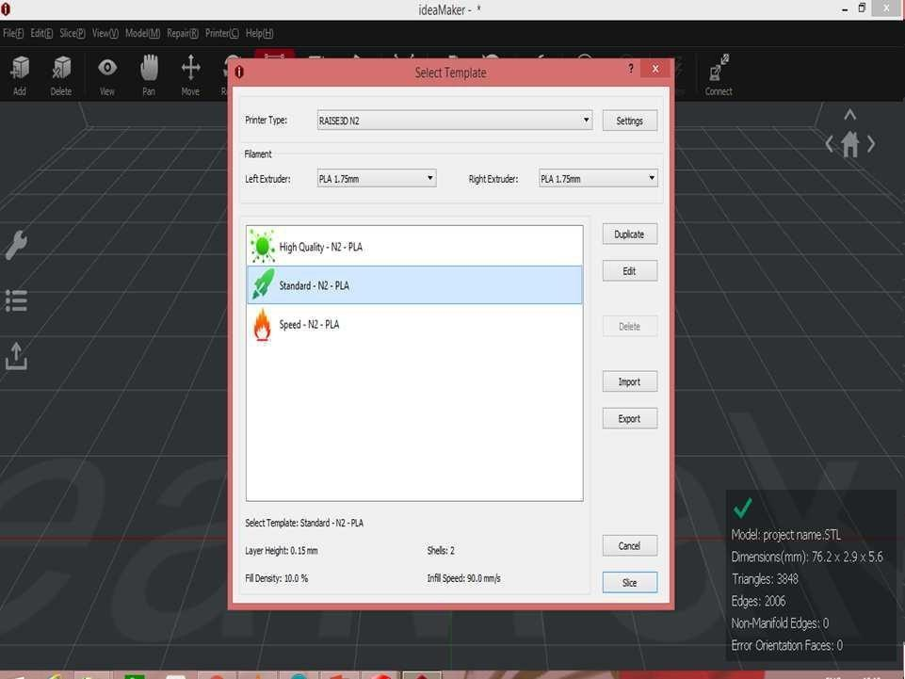

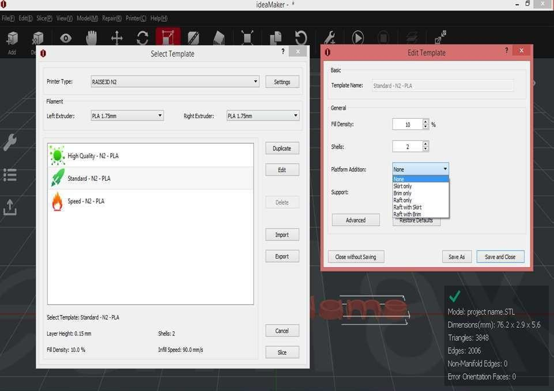

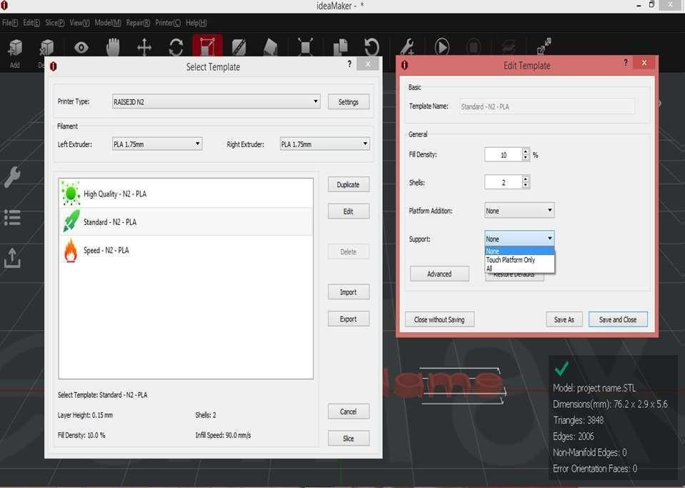
Step 4.:- After complete the all setting then click the Slice option and export the file in gcode formate.
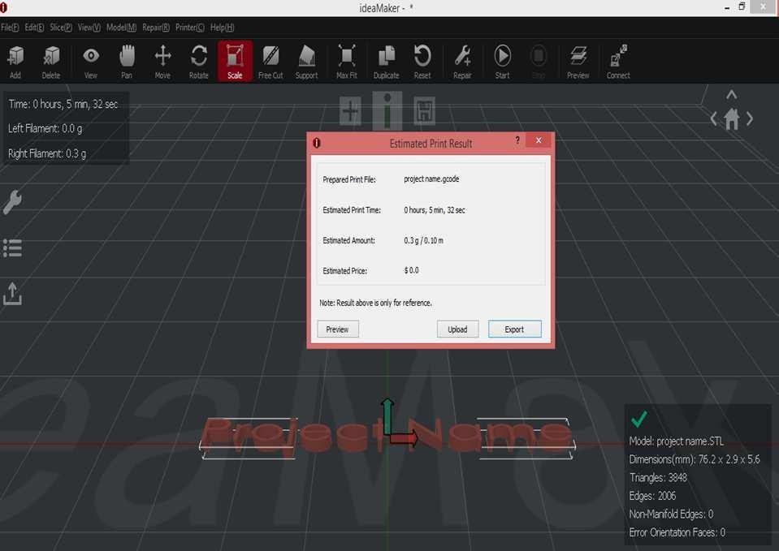

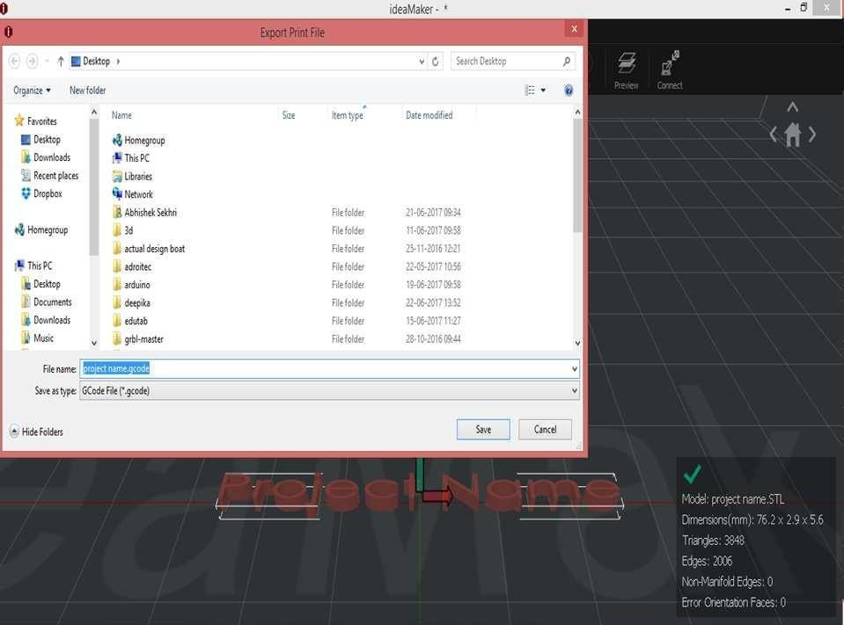
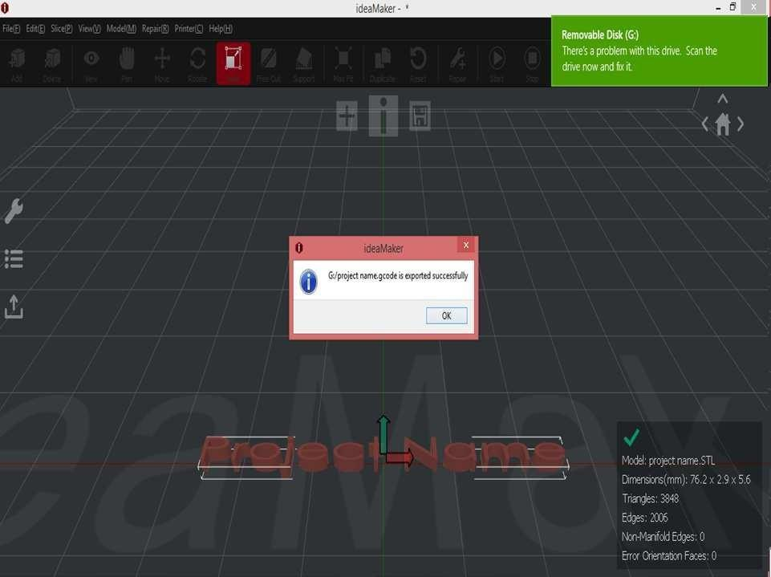

Step 5.:- After generate the gcode formate then follow the these instruction as shown in below figure.
- Switch on the 3d printer.

- Place your Pen drive in USB.

- Clean your surface bed plate.

- Load your filament into the required extruder as per the requirement.

- Wait until the nozzle & bed plate comes into the required temperature.

- Close the doors of 3d printer.

- Open the file from the USB storage and select the Print option.
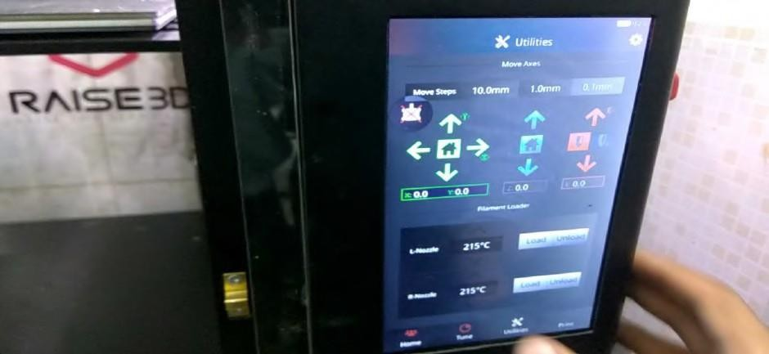
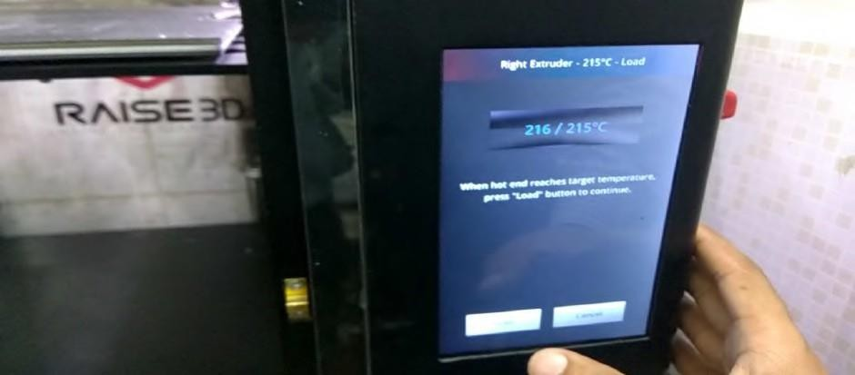

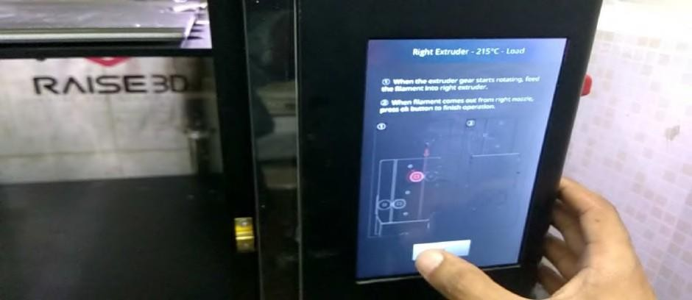
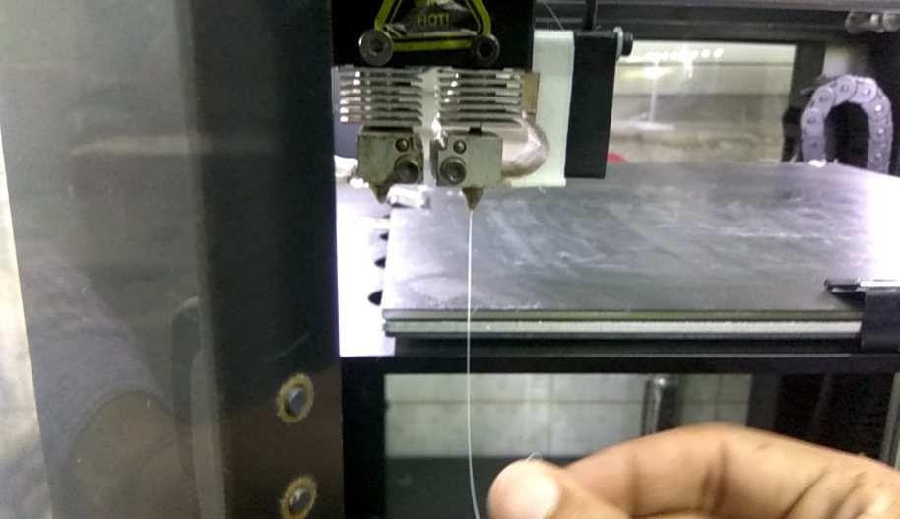
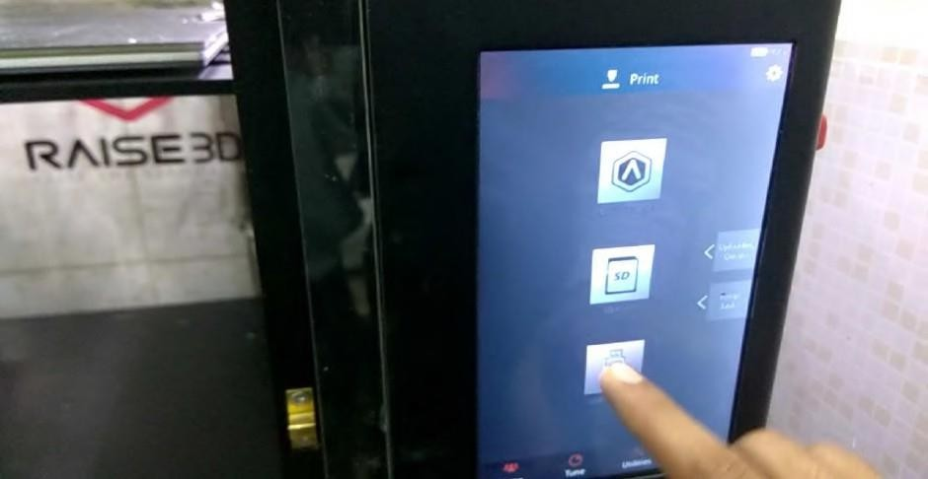

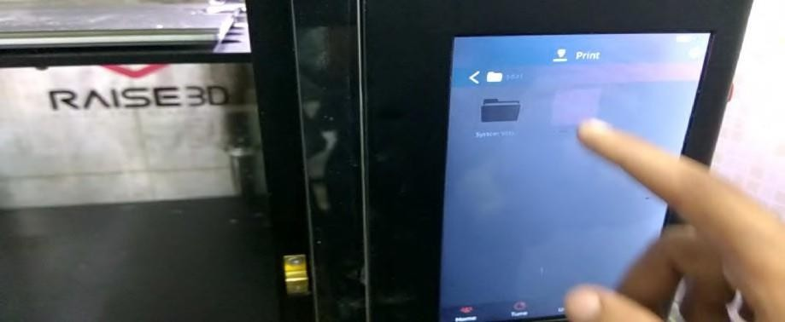

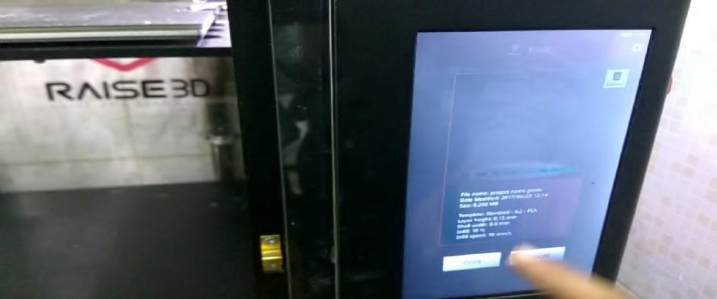

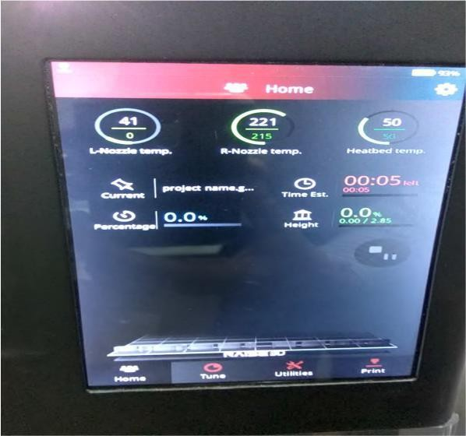

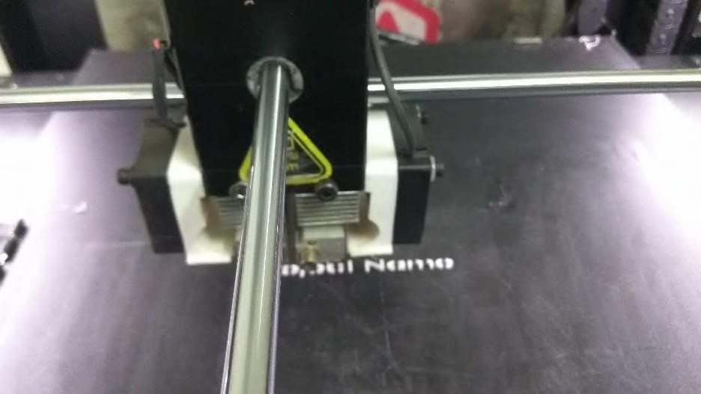
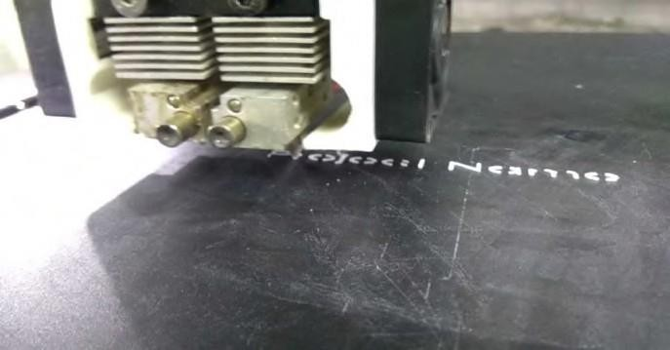
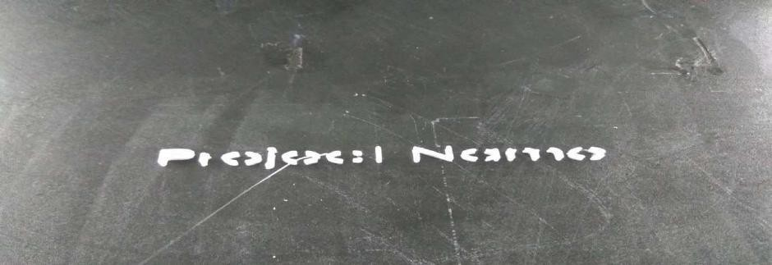

Exp 1: Modeling of Engineering component and conversion of STL format.

COVERSION OF STL COMPONENT
AIM: Modeling of engineering component and conversion of stl component
SOFTWARE REQURED: Soild works
Ultimaker cura software
HARDWARE REQUIRED: ANET FDM Machine, Key Board, mouse, cpu, PLA placement, cable connection

PROCEDURE:
- 3D model is created by using solid works software
- Dimensions are taken according to ASTM
- Then the 3D model is saved in to stl formate

Precautions:
- Created the 3D model without errors
- 2D models are not allowed only 3D models are allowed

RESULT:
Created 3D model converted in to STL formate

Exp 2: Slicing of STL file and study of effect of process parameter like layer thickness, Orientation and infill on build time using software.

Aim: Slicing of STL file and study of effect of process parameters like layer thickness, orientation and infill on buildtime using software.
Software Required: CAD Software[solidworks], Ultimaker Cura Software
Hard Required: ANET FDM Machine, keyboard, mouse, CPU, PLA Filament, Cable connection.
Procedure:
- 3D model is created by using solidworks software.
- Dimensions are taken according to ASTM Specimen.
- Then the 3D model is saved STL format.
- Now open the any slicing software that is ultimaker cura.
- Now go to the file click open.
- Click left button on the imported 3D model now it will shows the X,Y & Z directions dimensions.
- Now adjust the 3D model according to your 3D printer directions.
- Start the slicing process click the slice option by using left button of mouse.
- Now the imported 3D model is slicing.
- Now go to print setting icon click custom button.
- There once observe the quality , walls , top/bottom , infill , material , speed, travel, cooling , support , build plate adhesion , dual extrusion , special modes and the experimental parameters.
- Now select the infill icon and select different infill density , infill line distance . infill line multiplier , infill overlap percentage , infill layer thickness and gradual infill steps.
- Different orientation also selected and infill on bulid also selected,
- With use of cable connection model is given printing with time of 1 hour and 5 min with 20 grams.

Precautions:
- Create the 3D model without errors.
- 2D models are not allowed only 3D models are allowed.

Result:
The slicing of STL file and study of effect of process parameters like layer thickness, orientation and infill on buildtime using software can be created.
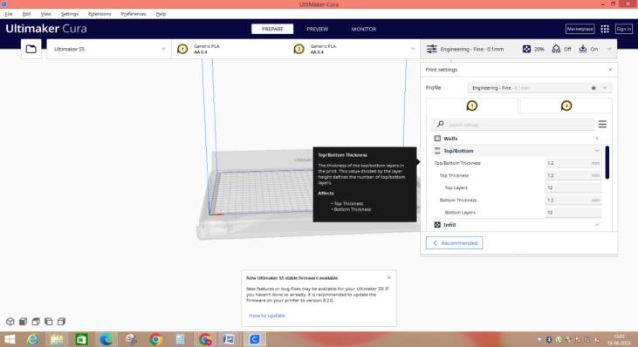

Module 2:
Exp 1 : 3D Printing of modeled component by varying layer thickness. Aim: 3D Printing of modeled component by varying layer thickness. Software Required: CAD Software[solidworks], Ultimaker Cura Software
Hard Required: ANET FDM Machine, keyboard, mouse, CPU, PLA Filament, Cable connection.

Procedure:
- 3D model is created by using solidworks software.
- Dimensions are taken according to ASTM Specimen.
- Then the 3D model is saved STL format.
- Now open the any slicing software that is ultimaker cura.
- Now go to the file click open.
- Click left button on the imported 3D model now it will shows the X,Y & Z directions dimensions.
- Now adjust the 3D model according to your 3D printer directions.
- Start the slicing process click the slice option by using left button of mouse.
- Now the imported 3D model is slicing.
- Now go to print setting icon click custom button.
- There once observe the quality , walls , top/bottom , infill , material , speed, travel, cooling , support , build plate adhesion , dual extrusion , special modes and the experimental parameters.
- Now select the infill icon and select different infill density , infill line distance . infill line multiplier , infill overlap percentage , infill layer thickness and gradual infill steps.
- Different orientation also selected and infill on bulid also selected,
- With use of cable connection model is given printing with time of 1 hour and 5 min with 20 grams.
- Different layer thickness are considered and taken print .

Precautions:
- Create the 3D model without errors.
- 2D models are not allowed only 3D models are allowed.
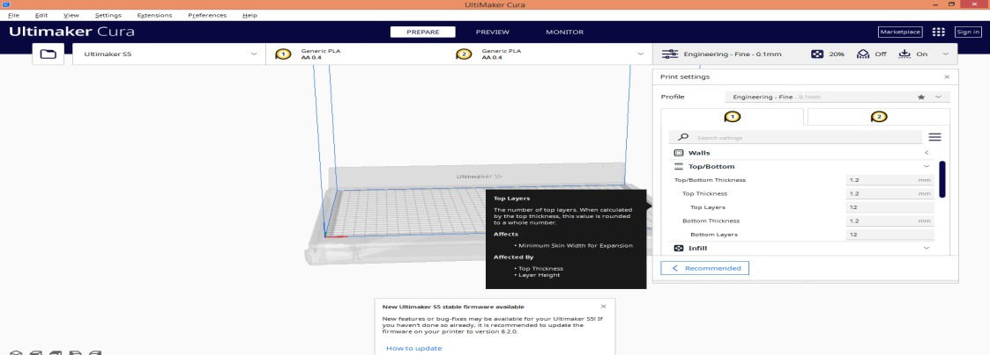
Result: 3D Model is created by varying layer thickness.

Exp 2 : 3D Printing of modeled component by varying orientation. Aim: 3D Printing of modeled component by varying orientation.
Software Required: CAD Software[solidworks], Ultimaker Cura Software
Hard Required: ANET FDM Machine, keyboard, mouse, CPU, PLA Filament, Cable connection.

Procedure:
- 3D model is created by using solidworks software.
- Dimensions are taken according to ASTM Specimen.
- Then the 3D model is saved STL format.
- Now open the any slicing software that is ultimaker cura.
- Now go to the file click open.
- Click left button on the imported 3D model now it will shows the X,Y & Z directions dimensions.
- Now adjust the 3D model according to your 3D printer directions.
- Start the slicing process click the slice option by using left button of mouse.
- Now the imported 3D model is slicing.
- Now go to print setting icon click custom button.
- There once observe the quality , walls , top/bottom , infill , material , speed, travel, cooling , support , build plate adhesion , dual extrusion , special modes and the experimental parameters.
- Now select the infill icon and select different infill density , infill line distance . infill line multiplier , infill overlap percentage , infill layer thickness and gradual infill steps.
- Different orientation also selected and infill on bulid also selected,
- With use of cable connection model is given printing with time of 1 hour and 5 min with 20 grams.
- Model is Printed with by varying orientation.

Precautions:
- Create the 3D model without errors.
- 2D models are not allowed only 3D models are allowed.
Result: •Model is Printed with by varying orientation.

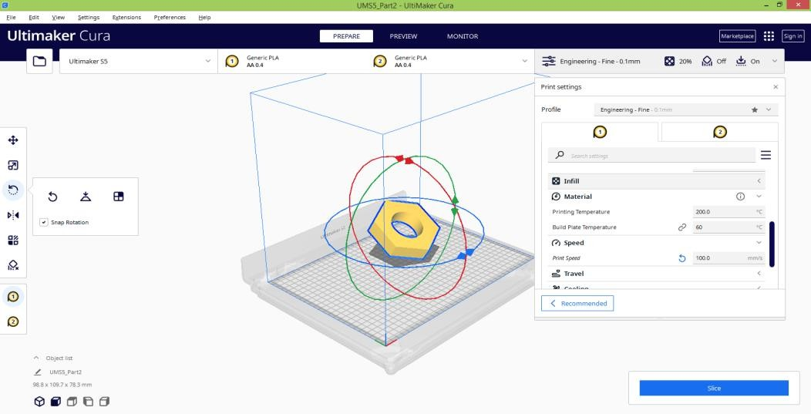

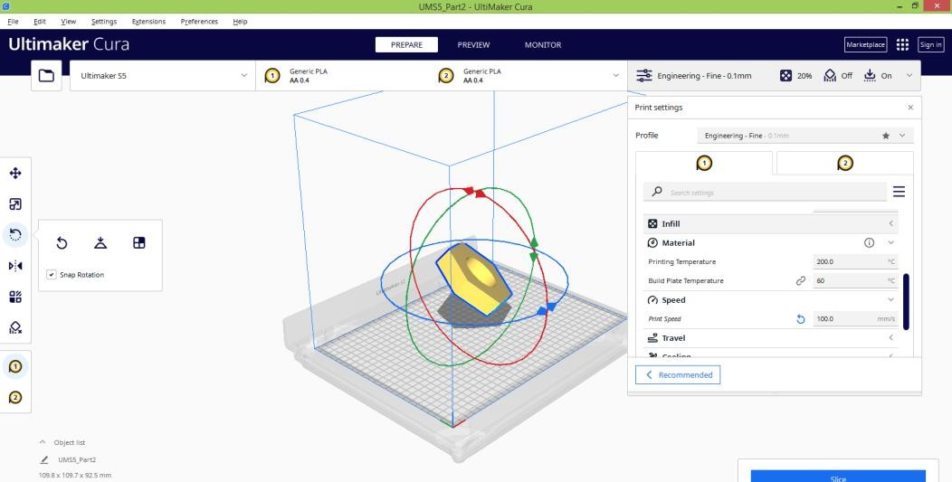

Exp 3: 3D printing of modeled component by varying infill.
Aim: 3D printing of modeled component by varying infill.
Software Required: CAD Software[solidworks], Ultimaker Cura Software
Hard Required: ANET FDM Machine, keyboard, mouse, CPU, PLA Filament, Cable connection.

Procedure:
- 3D model is created by using solidworks software.
- Dimensions are taken according to ASTM Specimen.
- Then the 3D model is saved STL format.
- Now open the any slicing software that is ultimaker cura.
- Now go to the file click open.
- Click left button on the imported 3D model now it will shows the X,Y & Z directions dimensions.
- Now adjust the 3D model according to your 3D printer directions.
- Start the slicing process click the slice option by using left button of mouse.
- Now the imported 3D model is slicing.
- Now go to print setting icon click custom button.
- There once observe the quality , walls , top/bottom , infill , material , speed, travel, cooling , support , build plate adhesion , dual extrusion , special modes and the experimental parameters.
- Now select the infill icon and select different infill density , infill line distance . infill line multiplier , infill overlap percentage , infill layer thickness and gradual infill steps.

Precautions:
- Create the 3D model without errors.
- 2D models are not allowed only 3D models are allowed.
Result: model is printed of modeled by varying infill.
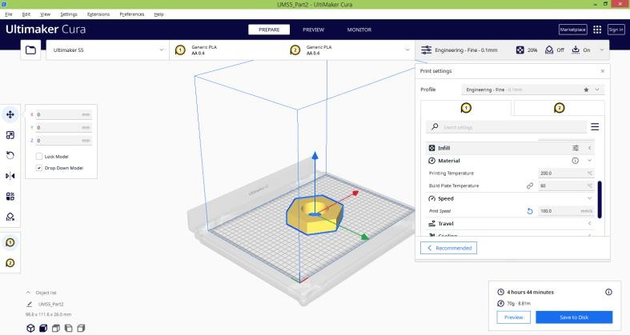

Module 3:
Study on effect of different materials like ABS, PLA, Resin etc, and dimensional accuracy.
Aim: Study on effect of different materials like ABS, PLA, Resin etc, and dimensional accuracy.
Software Required: CAD Software[solidworks], Ultimaker Cura Software
Hard Required: ANET FDM Machine, keyboard, mouse, CPU, PLA Filament, Cable connection.
Procedure: Materials used
- Materials: Thermoplastic powders (Nylon 6, Nylon 11, Nylon 12, etc.),
- metal powders (steel, titanium, aluminum, cobalt, etc.),
- ceramic powders
- The materials used for 3D printing are as diverse as the products that result from the process.
- As such, 3D printing is flexible enough to allow manufacturers to determine the shape, texture and strength of a product.
- Best of all, these qualities can be achieved with far fewer steps than what is typically required in traditional means of production.
- Moreover, these products can be made with various types of 3D printing materials.
- In order for a 3D print to be realized in the form of a finished product, a detailed image of the design in question must first be submitted to the printer.
- The details are rendered in standard triangle language (STL), which conveys the intricacies and dimensions of a given design and allows a computerized 3D printer to see a design from all sides and angles.
- Basically, an STL design is the equivalent of multiple flat designs in one computerized file.
- The industry for 3D printing is expected to surpass the 10-figure mark in the near future and plastic is set to be the main material to drive this market.
- As concluded recently in a SmarTech Markets Publishing study, the market for 3D printing is likely to exceed $1.4 billion before 2020.
- With an ongoing market expansion, the industry has sought new ways to yield plastics, including the use of organic ingredients like soybean oil and corn.
- Consequently, plastics are set to become the most environmentally friendly option in 3D printing.

PLASTIC
- Out of all the raw materials for 3D printing in use today, plastic is the most common.
- Plastic is one of the most diverse materials for 3D-printed toys and household fixtures.
- Products made with this technique include desk utensils, vases and action figures.

- Available in transparent form as well as bright colors — of which red and lime green are particularly popular — plastic filaments are sold on spools and can have either a matte or shiny texture.
- With its firmness, flexibility, smoothness and bright range of color options, the appeal of plastic is easy to understand.
- As a relatively affordable option, plastic is generally light on the pocketbooks of creators and consumers alike.
- Plastic products are generally made with FDM printers, in which thermoplastic filaments are melted and molded into shape, layer by layer.
- The types of plastic used in this process are usually made from one of the following materials:

Poly lactic acid (PLA):
- One of the eco-friendliest options for 3D printers, polyastic acid is sourced from natural products like sugar cane and corn starch and is therefore biodegradable.
- Available in soft and hard forms, plastics made from polyastic acid are expected to dominate the 3D printing industry in the coming years.
Hard PLA is the stronger and therefore more ideal material for a broader range of products

Acrylonitrile butadiene styrene (ABS):
- Valued for its strength and safety, ABS is a popular option for home-based 3D printers.
- Alternately referred to as “LEGO plastic,” the material consists of pasta-like filaments that give ABS its firmness and flexibility.
- ABS is available in various colors that make the material suitable for products like stickers and toys.
- Increasingly popular among craftspeople, ABC is also used to make jewelry and vases.

Polyvinyl Alcohol Plastic (PVA)
- Used in low-end home printers, PVA is a suitable plastic for support materials of the dissolvable variety.
- Though not suitable for products that require high strength, PVA can be a low-cost option for temporary-use items.

Polycarbonate (PC)
- Less frequently used than the aforementioned plastic types, polycarbonate only works in 3D printers that feature nozzle designs and that operate at high temperatures. Among other things, polycarbonate is used to make low-cost plastic fasteners and molding trays.
- Plastic items made in 3D printers come in a variety of shapes and consistencies, from flat and round to grooved and meshed.
- A quick search of Google images will show a novel range of 3D-printed plastic products such as mesh bracelets, cog wheels and Incredible Hulk action figures.
- For the home craftsperson, polycarbonate spools can now be purchased in bright colors at most supply stores.

RESINS
- One of the more limiting and therefore less-used materials in 3D printing is resin.
- Compared to other 3D-applicable materials, resin offers limited flexibility and strength.
- Made of liquid polymer, resin reaches its end state with exposure to UV light.
- Resin is generally found in black, white and transparent varieties, but certain printed items have also been produced in orange, red, blue and green.
- The material comes in the following three categories:
- High-detail resins: Generally used for small models that require intricate detail. For example, four-inch figurines with complex wardrobe and facial details are often printed with this grade of resin.

METAL
- The second-most-popular material in the industry of 3D printing is metal, which is used through a process known as direct metal laser sintering or DMLS.
- This technique has already been embraced by manufacturers of air-travel equipment who have used metal 3D printing to speed up and simplify the construction of component parts.
- DMLS printers have also caught on with makers of jewelry products, which can be produced much faster and in larger quantities — all without the long hours of painstakingly detailed work — with 3D printing.
- Metal can produce a stronger and arguably more diverse array of everyday items. Jewelers have used steel and copper to produce engraved bracelets on 3D printers.
- Stainless-steel: Ideal for printing out utensils, cookware and other items that could

CARBON FIBER
- Composites such as carbon fiber are used in 3D printers as a top-coat over plastic materials.
- The purpose is to make the plastic stronger.
- The combination of carbon fiber over plastic has been used in the 3D printing industry as a fast, convenient alternative to metal.
- In the future, 3D carbon fiber printing is expected to replace the much slower process of carbon-fiber layup.
- With the use of conductive carbomorph, manufacturers can reduce the number of steps required to assemble electromechanical devices.

Results
Study on effect of different materials like ABS, PLA, Resin etc, and dimensional accuracy are carried out.

Module 4:
Identifying the defects in 3D Printed components.

Aim: Identifying the defects in 3D Printed components.
Software Required: CAD Software[solidworks], Ultimaker Cura Software.
Hard Required: ANET FDM Machine, keyboard, mouse, CPU, PLA Filament, Cable connection.

Procedure:
The most common defects and problems in 3D printing
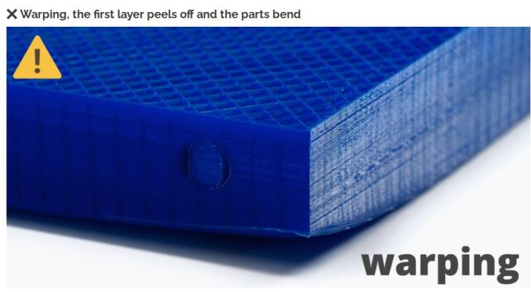
We have put together a collection of the most common problems that arise when using our 3D printer. They are the same problems that we commonly encounter in our online 3D printing service, and so we have quite a bit of experience dealing with and solving them. A well calibrated printer, correct lamination and an experienced operator are key to avoiding these problems. By having that you will be able to solve any printing problem. If you experience any of these issues, follow the instructions we give you and if you still can’t solve them, you have the comment box at the end of the article to tell us your doubts.

- ack of adhesion to the bed: this can occur due to incorrect height of the nozzle in relation to the base, or poor leveling; but also lack of adhesion to the printing surface.
- Thermal contraction of the upper layers, which when “shrinking” pull on the lower layers. If this occurs, the print surface may even break if it is a BuildTak type, as the sticker will be torn off the bed. This can also happen with glass. This happens mostly with materials such as ABS or Nylon, and it is very difficult for it to happen when printing PLA.
- ack of adhesion to the bed: this can occur due to incorrect height of the nozzle in relation to the base, or poor leveling; but also lack of adhesion to the printing surface.
- Thermal contraction of the upper layers, which when “shrinking” pull on the lower layers. If this occurs, the print surface may even break if it is a BuildTak type, as the sticker will be torn off the bed. This can also happen with glass. This happens mostly with materials such as ABS or Nylon, and it is very difficult for it to happen when printing PLA.

❌ Cracking or delamination
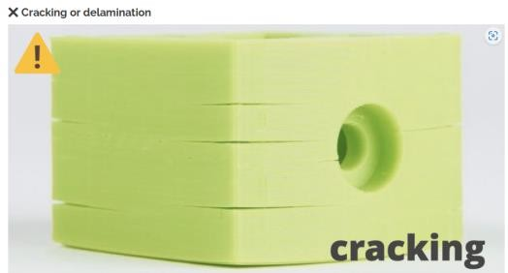
- Poor adhesion between the layers: the layers do not stick properly to each other.
- Thermal shrinkage: the layers stick together well, but a difference in temperature between different sections of the part causes it to deform, which can cause some layers to separate.
❌ Layer shift
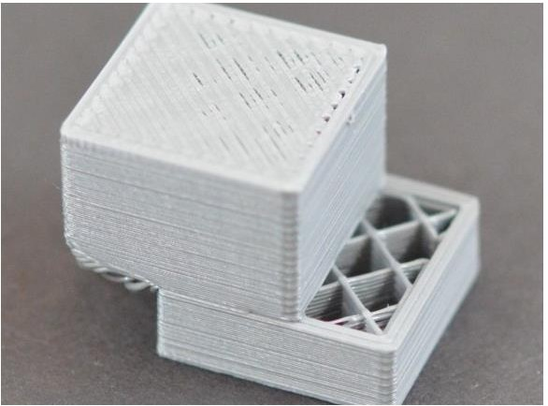

- Excessive temperature in the motors, or drivers: the electronics in general are not designed to operate continuously at a very high temperature.
- Lack of power in the motors, usually caused by a very low voltage value in the drivers.
- Mechanical failure: it can happen that we have some of our belt’s teeth broken, or there is some debris on the shafts that can cause a jam in the movement of our printer. Sometimes a wrongly tightened component can also cause layer displacement defects when the whole shaft moves freely.

❌ Z-wobble
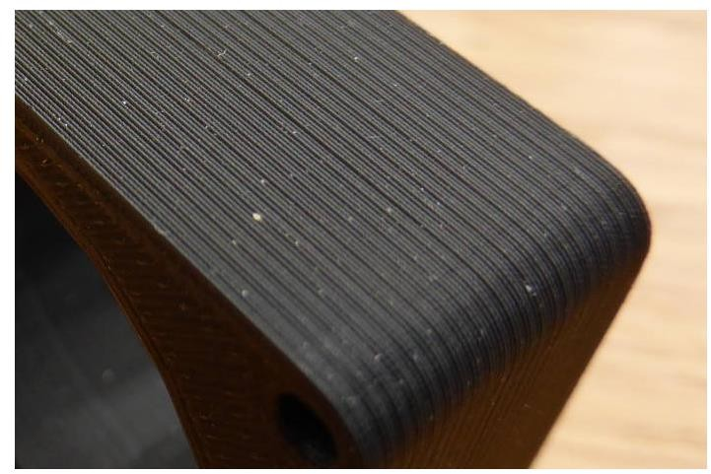
This problem can be difficult to identify, as it is often not easy to distinguish it from a simple inconsistency in the extrusion. To identify it we must look at whether this inconsistency is repeated on a regular basis. If it seems random, or just noise in general, your problem is probably not z-wobble but an extrusion problem. Conversely, if there seems to be a pattern that repeats periodically such as waves on the surface, you may well have a problem with your Z-axis.

Results: we identified the defects in 3D Printed components.

Module 5
Exp1: Modelling of component using 3D Scanner of real life object of unknown dimension in reverse engineering.

Aim: Modelling of component using 3D Scanner of real life object of unknown dimension in reverse engineering.
Software Required: CAD Software[solidworks], Ultimaker Cura Software.
Hard Required: ANET FDM Machine, keyboard, mouse, CPU, PLA Filament, Cable connection.

Procedure:
3D scanning and its classification
3D Scanning is a quick and precise process of converting physical objects into digital form. It digitally recreates an object by capturing its coordinates (x, y, z). Many industries are employing reverse engineering to reduce the cost and time of product development & design and manufacturing. Collecting the existing data from the physical objects can speed up using a 3D scanner (Alcácer & Cruz-Machado, 2019; Kot et al., 2021). 3D Scanning is a method that can quickly generate a digital duplicate of reality. It is an excellent technique for creating custom items that fit a person precisely. A completed section is scanned using a cloud scanner in 3D points. Then it is progressively created and reintegrated into a different mesh structure in a CAD drawing. It can be amended for finishing and tolerance, and eventually, a new design is ready to be created and merged occasionally with CAM software. This technology is becoming more advanced and accurate for meeting design challenges. Different types of 3D scanning process areas
- Structured light 3D Scanning
- LASER triangulation 3D scanning
- Structured light 3D Scanning Photogrammetry.
Coordinate measuring machine (CMM) (Contact-based 3D Scanning) Working steps of 3D scanners
3D scanners are highly accurate, which is why a significant increase in the reverse engineering industry is predicted. A 3D scan is a 3D picture of the portion of the surface of an item. A 3D model is a set of 3D images. 2D photographs consist of pixels, and 3D scans consist of triangles or polygons. The polygons create a multi-purpose mesh, which in minute detail duplicates item geometry. In a variety of industry sectors, from production to healthcare, 3D scanners are being employed. It is helpful for heavy machines, quality control of mechanical components, tailored prosthesis devices, visual effects for films, and character development for video gaming (Haleem & Javaid, 2019; Ling, 2021; Sepasgozar, Shi, Yang, Shirowzhan & Edwards, 2020). The working steps of 3D scanners are as under:

D scanning applications for Industry 4.0
3D scanners have substantially improved technology, making them more accessible and cheaper. Industry 4.0 can help examine some of the real-world 3D scanning applications. This technology is helpful in classrooms worldwide and is becoming widespread (Moroni & Petrò, 2018; Villalba-Diez et al., 2019; Wertjanz, Kern, Csencsics, Stadler & Schitter, 2021). In many cases, industries employ 3D data from goods to assist in product design. Furthermore, 3D printing is one of the most remarkable new uses of the 3D scan. 3D printing allows the printing of objects or models in various dimensions. The capacity to plan future activities and prototypes is one of the most practical applications of 3D Scanning for Industry 4.0 (Hofmann & Rüsch, 2017; Roldán, Crespo, Martín-Barrio, Peña-Tapia & Barrientos, 2019; Rousselle, 2021; Seo, 2021). The 3D models are built by measuring different views with laser dots or lines. Thousands of lasers and computer-based data points are organised into point clouds. These dot clouds have coordinated with x, y, and z values. The data and details in these points allow users to digitally create the most realistic models (Facchini, Oleśków-Szłapka, Ranieri & Urbinati, 2020; Fernández Álvarez et al., 2021; Kohtala, Erichsen, Wullum & Steinert, 2021; Mehami, Nawi & Zhong, 2018). Table 1 briefs the 3D scanning application areas for Industry 4.0.

Working process of 3D scanning for reverse engineering
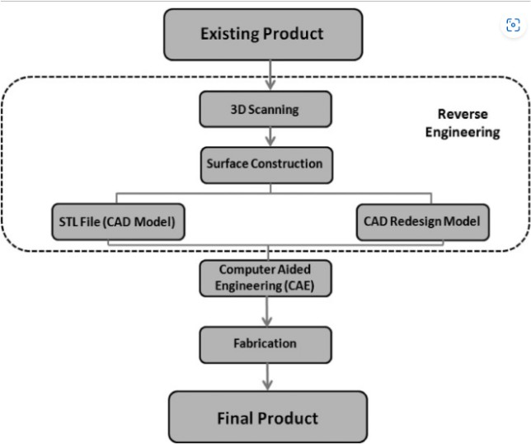
Reverse engineering, along with 3D Scanning and 3D printing, is a powerful technique for developing digital designs from physical parts, and it may be a valuable tool in the prototyping toolset. 3D scanners can quickly measure complicated items and significantly speed up the design workflow when real-life references are used. With the capacity to record and modify actual shapes, 3D-printed parts may be designed to fit flawlessly on various existing items. Jigs of 3D printed plastic can repeatedly position a drill or saw or precisely join parts with glue (Dalmarco & Barros, 2018; Krowicki et al., 2018; Marchewka & Grudzinski, 2021). Make reusable masks that fit snugly for sandblasting, painting, or etching. Fig. 1 shows the product development process flow using reverse engineering and 3D Scanning.

Result: Modelling of component using 3D Scanner of real life object of unknown dimension in reverse engineering.

